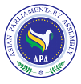

APA/ Decision/2016/01
1December 2016

APA Decision
on
The Deliberations in Executive Councils & Plenary

Any technical comments or editorial corrections in the draft resolutions during Executive Council meetings or Plenary session are permitted and may be incorporated into the text, however, further substantial discussion on paragraphs should be forwarded to the relevant Standing Committees.

